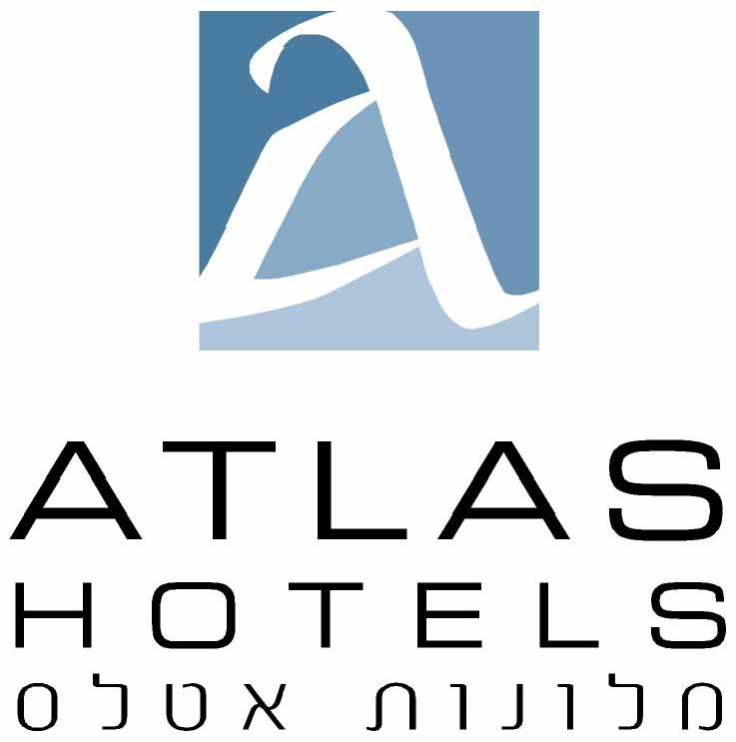

42 hamasger Tel Aviv Israel Tel: 972-3-5425555, Fax: 972-3-7608920 E-mail : ayelet@atlashotels.co.il

DATE: | July 11, 2018 | REF: | 21512
ATTENTION: | Reservations – Ayelet Giat shirayec@gmail.com
Tel Aviv University-
Advances in Applied Mathematics
18-20/12/18
HOTEL:
Room type:
Single:
Double:
Guest name :
Arrival date:
Check-in 14:00:
Departure date
Check-out 12:00
Credit card details for the guarantee: | №:
 | Expiration date: ____ / ____
Card holder’s name
(if different than guest name)
Contact information (tel / email) :
Shalom hotel:
The rate per single room per night including breakfast:770. nis
The rate per double room per night including breakfast:847 . nis

Melody Hotel / Tal hotel:
The rate per single room per night including breakfast:600. nis
The rate per double room per night including breakfast:660 . nis

Yam / Cinema / Center Chic Hotels:
The rate per single room per night including breakfast:565. nis
The rate per double room per night including breakfast:610 . nis

Israeli passport holders need to add VAT to the rate.

Reservations upon availability only.

please send the form to: noa@atlashotels.co.il / stav@atlashotels.co.il

